Statement of Work (SOW)

Project – Akasha A Cross-Platform Intelligence System

1. Executive Summary
Akasha, is a cross-platform intelligence system that brings together planning, execution, connectivity, logistics, and procurement data into a single dashboard with AI-driven decision support. Unlike traditional dashboards, Akasha includes an AI-powered chatbot that not only provides visibility but also simulates scenarios, recommends actions, and shows potential outcomes before decisions are made. This enables faster decision-making, better coordination, reduced risk, and more efficient project execution.

2. Background & Strategic Mandate
Project data is currently spread across multiple enterprise platforms, causing delays and inconsistent reporting. This initiative aims to create a connected ecosystem where essential project data moves seamlessly, giving stakeholders timely and clear visibility across all project stages.

3. Objective of the Engagement
The main objective is to eliminate disconnected project execution by integrating planning, site progress, connectivity readiness, DPR reporting, logistics, CAPEX, and SAP financial systems into a centralized, real-time monitoring framework. This will provide leaders with a single view of project health and enable timely operational and financial decisions.

4. Scope of Work

4.1 User & Access Model
User Personas
- Executive Leadership
- PMAG Team
- Project Heads / Site Leads
- Planning & Scheduling Teams
- Techno-Commercial Teams
- Business Development (BD)
- System Administrators
Access Model
- Role-Based Access Control (RBAC)
- Persona-based dashboards
- Controlled approvals (human-in-the-loop)
- Alerts and notifications
Authentication
- Enterprise Single Sign-On (SSO)

4.2 Functional Scope
The platform will enable:
- Centralized project monitoring across renewable portfolios
- Single consolidated, cross-platform view of project data (P6, SAP, DPR, Transmission)
- AI-powered chatbot for decision support and scenario simulation
- Scenario-based intelligence to simulate delays, risks, and operational situations
- Action-oriented recommendations with expected outcomes and impact analysis
- Automated alerts, triggers, and notifications for delays, risks, and dependencies
- Derived logistics intelligence using SAP and P6 data
- Material readiness tracking aligned with project schedules
- Financial and procurement visibility through SAP integration
- Cross-functional decision support for PMAG, Projects, Techno-commercial, BD, and Site teams
- Reduction in manual coordination, follow-ups, and spread communication
- Executive dashboards for leadership visibility and strategic insights

4.3 Data & Integration Systems
Primavera P6
- Act as the core planning and scheduling engine, supporting work breakdown, activities, baselines, and tracking planned vs actual progress with deviation alerts.
- Manage activity sequencing, milestones, and dependencies, while identifying delays and monitoring the critical path with automated alerts
- Enable resource allocation and utilization tracking, highlighting over/under utilization for better planning.
- Integrate with Digital DPR for real-time updates and ensure continuous alignment between plan and execution.
- Improve overall schedule control, risk visibility, and decision-making.
Transmission Connectivity Dashboard
- Track grid connectivity, evacuation capacity, and interconnection milestones for overall transmission visibility.
- Use the historical data and analyse past timelines (SCD) to identify delay patterns and improve timeline accuracy.
- Generate realistic, data-driven projections and adjust timelines (e.g., 4 → 9 months) considering approvals, dependencies, and execution challenges.
- Enable execution-based planning (ECOD) by aligning planning and financial decisions with actual timelines.
- Improve forecasting, risk identification, capital alignment, and overall decision-making predictability.
Digital DPR (Daily Progress Report)
- Centralized Digital DPR system to capture and monitor daily project progress (replacing Excel)
- Data access restricted to only the last 7 days to maintain data integrity; any modification within these last 7 days data requires a mandatory reason
- Seamless integration with Primavera P6 to enable real-time synchronization of approved progress data and ensure alignment between planned schedules and actual execution
- Support role-based access control (Supervisor, Site PM, PMAG Admin) with capabilities for project assignment and controlled cross-project visibility
- Defined approval workflow where Supervisor submits DPR, Site PM approves, and only approved data is pushed to P6
- Provide real-time dashboards and project summaries, along with tracking of delays, issues, and dependencies, supported by automated alerts and notifications
- Improve data accuracy, reduce manual effort, enhance coordination, and enable better decision-making
Module Tracker
- Provide end-to-end material tracking from manufacturing to site, including production status, shipment visibility, and monitoring of ETA and transit delays
- Ensure alignment with Primavera P6 schedules, highlighting any mismatch between material availability and planned activities
- Integrate with SAP for CAPEX tracking to align material movement with financial planning
SAP
- Manage end-to-end procurement lifecycle with real-time updates
- Track PO/SO amendments with full visibility and impact on project timelines and costs
- Enable CAPEX monitoring and approval workflows aligned with project execution
- Provide inventory visibility and material tracking to support planning and reduce shortages
- Support financial decision workflows integrated with project data for better control and decision-making
- Cost breakdown structure for projects.
CMP (Cash Management Product) (to be excluded)
- Enable quarter-wise cash planning and tracking with actual vs predictive analysis
- Identify and explain cash flow variances, including issues causing deviation from planned targets (e.g., delays, approvals, execution gaps)
- Integrate with SAP and project data (P6/DPR) to align cash flow with project execution
Provide predictive forecasting to support financial control, risk
identification, and decision-making
Human-in-the-Loop Controls
- Ordering and dispatch approvals
- Site readiness validation by Project Heads
- PO Amendments- Scheduling changes
- Financial approvals (LC/BG/WC decisions)

4.4 Analytics Scope
- Real-time project progress analytics
- Schedule variance and delay detection
- Critical path impact analysis
- Connectivity readiness risk indicators
- Logistics flow intelligence
- Performance dashboards
- AI driven recommendation based on the analysis of scenarios
- Executive insights

5. Technical Architecture & Security
Architecture Overview
- Web-based centralized dashboard platform
- API-led integration architecture
- Modular microservices-based integration layer
- Central data aggregation and transformation layer
- Near real-time data pipelines
Integration Approach
- Push APIs for execution and logistics systems
- Pull APIs for planning and reporting systems
- Event-driven update mechanisms
Infrastructure
- Cloud-hosted or enterprise data center deployment
- Scalable compute and storage architecture
- High-availability environment
Security Framework
- Encrypted data in transit and at rest
- Role-based and policy-based access controls
- Secure API gateways
- Audit logs and activity monitoring
- Compliance with enterprise IT security policies

6. Delivery Phases & Milestones

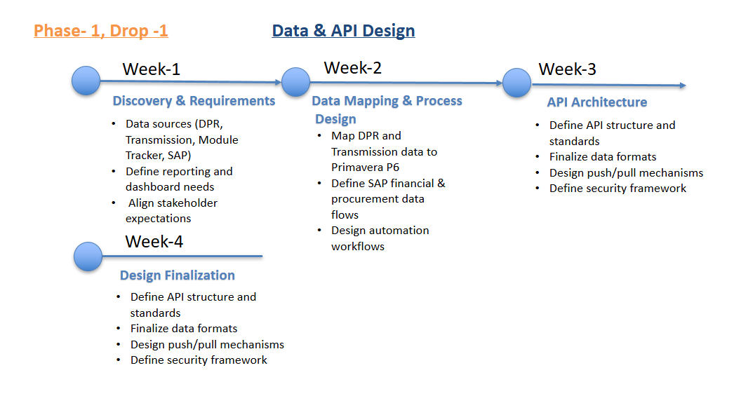

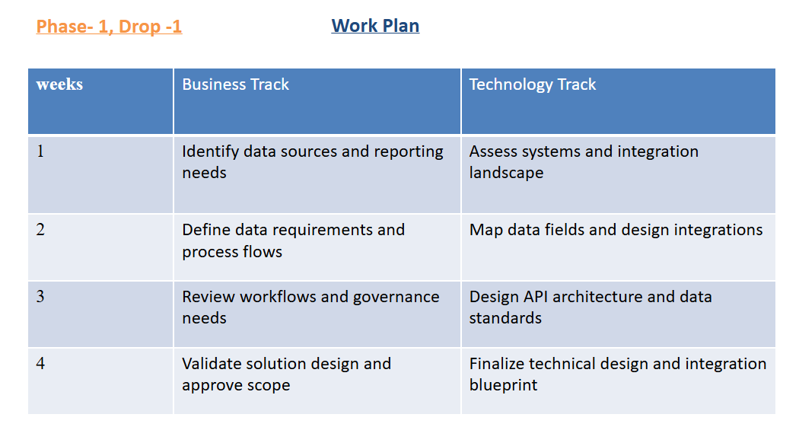

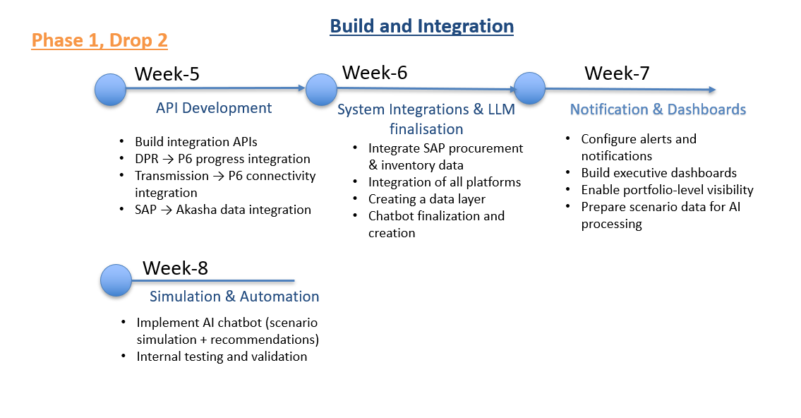

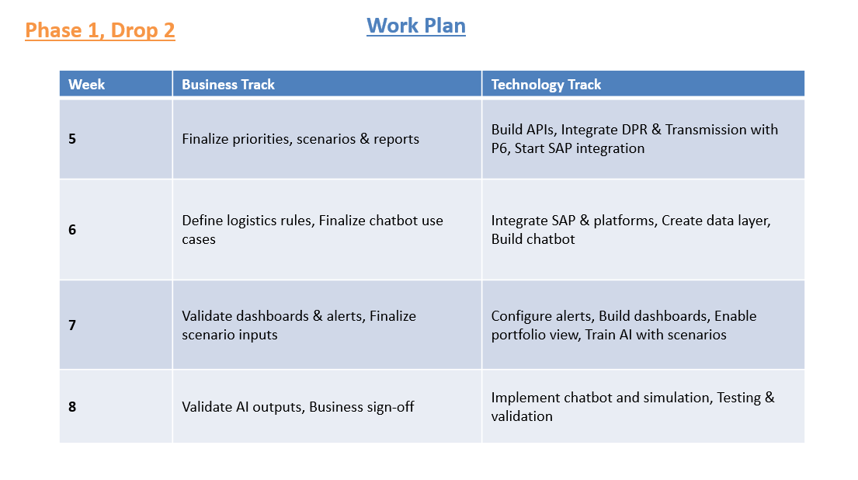
7. Deliverables
- Design and deployment of a unified leadership workspace that brings together data from all portfolio systems into a single, easy-to-use environment.
- API-led integration of key systems including Oracle Primavera P6, Transmission Connectivity Dashboard, Digital DPR, and SAP.
- Development of a logistics intelligence layer within Akasha, using SAP and P6 data to track material readiness and movement (in place of Module Tracker).
- Creation of a consolidated data layer that acts as a single source of truth across planning, execution, connectivity, logistics, procurement, and financials.
- Development of a portfolio-level dashboard to support leadership with real-time visibility, performance tracking, and better decision-making.
- Deployment of an AI-powered layer (LLM-based) to enable:
o Natural language interaction with project data
o Decision support through conversational insights
o Context-aware recommendations and next-best actions
o Scenario simulation to understand the impact of decisions before execution
- Enablement of role-based AI assistants for different functions such as projects, procurement, logistics, and finance.
- Configuration of alerts, notifications, and risk triggers across systems to keep teams proactively informed.
- Implementation of human-in-the-loop controls for key decisions such as approvals, dispatch, and financial actions.
- Support for cross-system actions through recommendations, reducing manual follow-ups and improving coordination (with execution remaining manual in Drop 1).
8. Out of Scope & Assumptions
Out of Scope
- Development of new enterprise source systems
- Hardware procurement and on-site infrastructure setup
Assumptions
- Existing systems support API integrations
- Source system data accuracy and ownership remain with system owners
- Required stakeholder availability for approvals and testing
9. Acceptance Criteria, KPIs & SLAs

Functional Accuracy & Utility
- Dashboard Data Accuracy: Consistent alignment between Primavera P6, Digital DPR, Transmission Connectivity, Module Tracker, and SAP data.
- DPR Submission Completeness: Site progress reports submitted through the digital DPR system and tracked via system submission logs.
- Alert Trigger Accuracy: Reliable automated alerts for delays, connectivity status, logistics movement, and financial updates, monitored through audit logs.
- Critical Path Update Latency: Timely reflection of schedule and milestone updates in Primavera P6 following DPR and connectivity data synchronization, tracked via API timestamps.
- Financial Data Reconciliation: Alignment between SAP CAPEX and procurement data with project execution records, validated through finance reconciliation reports.
- Scenario Simulation Accuracy: System accurately simulates impact of delays and operational changes across schedule, resources, and procurement
- Recommendation Effectiveness: AI-generated recommendations are relevant, actionable, and aligned with business decisions
- Chatbot Interaction Quality: Users are able to query project data and receive clear, context-aware insights
- Finance related query- User would be able to get the revenue related answers.

Performance
- Dashboard Performance: Fast and responsive dashboard experience for project views.
- API Performance: Efficient and stable API communication across integrated systems.
- Data Pipeline Timeliness: Near real-time data synchronization across Primavera P6, Digital DPR, Transmission Connectivity, Module Tracker, and SAP
- Batch Processing Efficiency: Timely completion of scheduled data processing and system jobs
- Chatbot Response Time: Responses generated within acceptable time for real-time interaction
- Scenario Processing Time: Simulation outputs generated within defined time limits

Security & Compliance
- Access Control Enforcement: Role-based access applied across all user personas with periodic access reviews and audit validation.
- Security Testing & Hardening: Platform undergoes security assessments before go-live to identify and remediate vulnerabilities.
- Audit & Activity Logging: End-to-end logging of user actions, data changes, approvals, and cross-platform transactions for traceability.
- API Security Management: Secure API usage across integrated systems with hidden credentials, controlled access tokens, and periodic key rotation.
- Integration Security Controls: Protected data exchange between Primavera P6, DPR, Transmission Connectivity, Logistics, and SAP through encrypted channels and secure gateways.
- Secure AI Interaction: Chatbot access and responses restricted based on user roles and permissions
- Data Privacy in AI Processing: Sensitive project and financial data handled securely within AI workflows
- Auditability of AI Actions: All chatbot queries, recommendations, and scenario outputs logged for traceability

Reliability
- Platform Stability – The integration platform should always be available and working without interruptions.
- Integration Reliability – The platform keeps data in sync across all connected systems. APIs work reliably and keep data accurate. If a data transfer fails, the system automatically retries to keep information flowing smoothly.
- Data Reliability – The platform prevents duplicate, incomplete, or conflicting data updates. It also makes sure updates across systems are completed correctly.
- Fault Handling & Recovery – The system can detect errors, send alerts, and follow clear steps to fix issues quickly.
- Monitoring– The platform continuously monitors system health and data integrations. System logs help teams quickly find and fix problems.
- AI System Stability: Chatbot and scenario engine remain consistently available without failures

Adoption
- Reporting Reduction: Reduced manual reporting and follow-ups through automated dashboards and integrated data flows.
- Decision Support Adoption: Teams refer to AI recommendations during planning and execution decisions
- User Satisfaction: Positive user experience and acceptance across leadership and project teams, assessed through periodic feedback and usage reviews.

10. RACI (Condensed)
Workstream | Company | Vendor
Data access approvals & governance policies | R | C
Data pipeline architecture & data quality | A | R
LLM deployment approach & model selection | A/R | C
Technology stack selection | A/R | C
Reasoning model design & configuration | C | A/R
Unified platform architecture & setup | C | A/R
System integration & API enablement | C | A/R

